Questionnaire:

***1. Is the role of Gazprom & Itera and of Russian capital in general in the Latvian energy market considered a problem? Is this situation viewed similarly by everyone or are there differing opinions?***

I would say these are two different issues. Gazprom and Itera Latvija got their shares of Latvijas Gāze as the result of a privatisation agreement between the Latvian state and the new shareholders in 1997 and have been shareholders with changing proportions since. Although Gazprom represents Russian capital quite clearly and Itera represents Russian capital indirectly the presence of this capital is very obvious and clear unlike the alleged influence of other capital of Russian origin. Also, Itera Latvija is a local company unlike Gazprom. However it is presumed that it is through Itera Latvija that the so called soft power activities are carried out; Itera Latvija sponsors ice-hockey and other sports and culture activities.

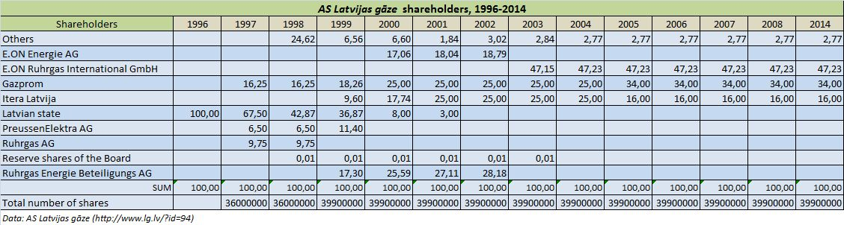

Other Russian capital in Latvian economy is something slightly different than Gazprom and Itera. A number of Latvian commercial banks have a fairly high share of deposits by non-residents. A few logistics and transport companies also have close relation with Russian capital.

***2. What importance does gas market regulation and in particular ownership unbundling have in Latvian energy policy? Is the status of Latvijas Gāze as a monopoly supplier and a vertically integrated utility seen as a problem in Latvian politics?***

The problem is that the decision-makers have demonstrated inability to think independently, to find and analyse information and draw conclusions. Giving in to the interests of Latvijas Gāze and Gazprom and Itera Latvija thereof is yet another example of vested interests that Russian capital and authorities affiliates with Latvia.

Natural gas has an important role in the energy portfolio; roughly 1/3 of electricity is produced in large CHPs (namely Riga CHP-1 and CHP-2) from natural gas. The share of natural gas in CHP generation (district heating + electricity) is over 93% while the share in boiler houses reaches 62%.

Latvijas gāze has been very successful in defending its interests in the government throughout the last 20 years and it is still very influential. Postponing the liberalisation of gas market just recently is yet another example of its influence on politics. Too few politicians understand the regulatory framework and therefore are making decisions that, from the strategic point of view, go contrary to the interests of the state.

***3. Are there major differences about gas market regulation among Latvian parties, industry associations, and perhaps other civil society groups (trade unions, ecological movements)?***

Large industrial producers like state owned energy incumbent Latvenergo in general largely opposes renewable energy and supports gas technologies. As to commenting the regulation, Latvijas Gāze has been very vocal on its own. Industry associations have been more general in their comments limiting their rhetoric to energy prices and not so much advocating gas in particular. One particular detail – district heating tariffs have constantly been lower in those municipalities, where biomass is used in heat production and tariffs have been higher, where natural gas has been used as the key energy resource. Thus, municipalities (especially the smaller ones and outside of the capital city Riga) tend to criticise gas while Riga says burning gas is more efficient. Still, it is more about prices than the gas market regulation.

***4. Would you say that one can see certain guidelines or priorities in Latvian energy policy over the last few years? More specifically, are there any drivers of policy making one can detect? For example, the 'Energiewende' in Germany, the attempt to turn away from nuclear energy and towards renewable, has been the general theme in German energy policy. Is there anything similar in Latvia?***

Latvian government adopted a long-term Energy strategy 2030 in May 2013 and this has been the official framework for policy planning. However, a number of decisions since the adoption of this strategy show that ad hoc decision-making is still the routine model. The government and the parliament postponed liberalisation of electricity market for households and liberalisation of gas market as well, thus hampering the implementation of the EU 3rd energy package. These decisions go contrary to the strategy and have purely political motivation – Latvia is having general election in October 2014, which puts pressure on politicians who are making populist decisions. Instead of elaborating and adopting an improved renewable energy support scheme the government and the Parliament adopted a new law on Subsidised Electricity Tax.

***5. In the official "Latvian Energy Long Term Strategy - 2030" the view is expressed that energy policy primarily has to serve economic growth and improve the competitiveness of Latvia's industry. The issue of energy security and in particular diminishing the dependence on Russian energy imports are considered less important. Would you confirm that supply security takes a less prominent role in Latvian energy policy than do purely economic considerations?***

I would actually say that unfortunately Latvia does not have energy policy in the meaning that there is a systematic, cohesive and sustainable policy in place and all decisions are derived from one common vision on the development of the energy sector. Strategy 2030 puts emphasis on low energy prices and the competitiveness of economy, but omits such important goals as supply risk minimisation and supply diversification both in the meaning of sources and routes of supply [of primary energy] and diversification of local supply – use of renewable resources for heat and power production (including in distributed energy production). IEA and the EU have clearly indicated that use of local energy resources and RES in particular adds significantly to the security of supply.

**6. What is your opinion on the nature of the policy making process? To what degree are decisions made on technical grounds or on considerations of daily politics? Do these decisions reflect a long-term vision or could they be regarded as being the result of politicking and presumably lobbying by interest groups? Could you give some indicators, why you would describe Latvian energy policy one way or the other?**

There is plenty of evidence that decisions related to natural gas market have been made without due analysis and without inviting neutral expertise. Technical aspects have indeed been used to argue in favour of one or another decision, but this has only served as a pretext for political decisions that have even not had hard legal backing. All Latvian governments over the last at least 10 years have been under strong influence of natural gas interests associated with Gazprom and Itera Latvija and presumably functioning as the cornerstone of the so-called soft-power ambitions of the only gas supplier. The decisions can be regarded as resulting from lobbying, but they have had long-term effects and the most recent vote by the Parliament only adds to this incompetent and biased decision-making.

**7. What do you think are the reasons that Latvia has delayed the implementation of the EU Third Energy Package for so long? Using at first an exemption in the directive as an 'energy island' for not opening its market for competition and then only deciding on March 13rd 2014 to demand full ownership unbundling of Latvijas Gāze (while Lithuania for example has done so in 2010).**

The decision by the Parliament on March 13 actually closed the gas market until April 2017. Unbundling was effectively postponed by this unanimous vote (91 “yes” (out of 100 votes in total) in favour of the amendments in the Energy Law postponing gas market liberalisation). The reason for such decisions is a very strong natural gas lobby that has effectively hampered any attempts to become less dependent on Russian gas. The decision, which now allows Latvijas Gāze to limit access to the transmission and distribution until full unbundling in presumably April 2017 makes Latvia and energy island, which it was not and would not be once Klaipeda LNG terminal is put in place at the end of 2014 and starts operations. The problem now is that LT will not be able to access LV gas transmission system since it has a legal backing to such potential behaviour by Latvijas Gāze. Latvijas Gāze new already in 2005 that the gas market liberalisation is set for April 4, 2014, but did everything to maintain its monopoly and control over all licensed commercial activity – transmission, distribution, storage and trade.

Reinis Āboltiņš

researcher, Centre for Public Policy PROVIDUS

[reinis.aboltins@providus.lv](mailto:reinis.aboltins@providus.lv)

+3711-29218999